Project 7: Using the Debugger

The purpose of this project is to learn to debug a broken website using the browser’s built-in debugger. You may use whatever browser you like. You will find that these browsers are your best two choices:

1. Chrome
2. Firefox with the FireBug extension.

# Application walk-through

I will present you with a description of a simple application for keeping contact info. The goal of this assignment is to get the app working, and to find / fix all bugs, typos, and minor glitches.

Attention to detail is important.

## Main screen

When you start the app, it will pre-load four contacts, and you’ll see them displayed in a list:

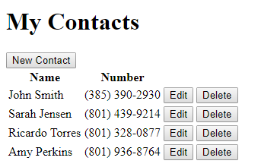

If you click the New Contact button, that’ll allow you to create a contact.

If you click the Edit button, that’ll allow you to edit a contact.

If you click the delete button, it should display a confirmation dialog like so:

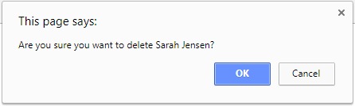

If you click cancel, it should not delete the contact. If you click OK, it will delete the contact.

## New Contact

When you click the New Contact button:

1. The main table should become hidden.
2. The edit contact form should appear.
3. The title should say New Contact
4. All input controls should be reset as shown in the image.
5. All validation messages should be hidden.

Screenshot:

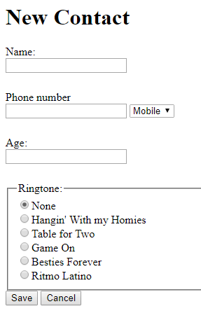

Only name, phone number, and age are required fields. The default phone number type is Mobile. The default Ringtone is None.

When validating age:

1. If the user enters a random string, give them an error message that the age is not a number.
2. If the user enters a negative number, or a number greater than 120, tell them the range.

## Edit a contact

When you click an edit button on the main form, the contact list will hide, and the edit window will appear. The form should populate with all the info for the contact.

Validation should work just like when creating a new contact.

Screenshot:

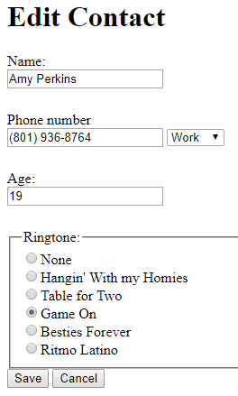

# Grading for this assignment

Five points per bug, with a minimum grade of 30%

Most students find all the bugs in the process of getting things to work.

Here is what I do to grade (actual steps may vary, but this is what I cover):

1. Launch the page and make sure it shows up.`
2. Click to edit an item.
3. Click save and make sure all validation messages show up
4. Click cancel to return to the form.
5. Click the create button to create a new item, create a new contact and then save.
6. Make sure it shows up in the list.
7. Edit the contact. Change all fields. Save. Edit the contact again and make sure all updates happened.
8. Delete the contact.

# Submitting your assignment

Zip up the Contacts folder and upload it to canvas.